Interim report on the internship
(Front end intern)

Student: Muskan Bhat
Student ID number: 636130
Degree programme: Bachelor’s Information technology
Email address: company ssg@ythewait.com

Client: Y the wait
Company supervisor: Simranjit Singh Grewal
Supervising lecturer: Eef Stavenuiter

Place: Rivium 4e Straat 3, 2909LJ Capelle aan den Ijssel

Date: 28-12-2020
Version: version 2

Contents
Contents
Contents 1
1. Introduction 2
2. Activities to date 2
2.1. Assignment 1 2
2.2. Assignment 2 2
3. Look ahead to Phase II 3
3.1. Schedule for assignments already started 3
3.2. Action plan for new assignments 3
3.2.1. Description 3
3.2.1.1. Scope 3
3.2.1.2. Preconditions 3
3.2.2. Approach 4
3.2.2.1. Products to be delivered 4
3.2.2.2. Approach: activities to be undertaken 4
3.2.2.3. Quality assurance 4
3.2.2.4. Schedule 4
3.2.2.5. Organisation 4
4. Reflection 5
5. Appendices 6
5.1 Gantt chart 6
5.3 The professional-attitude feedback form 8

Introduction
This is the interim document for the front end bootstrap, react JS-Redux internship I have started in “Y The Wait Operations BV”. My assignment is mainly divided into two parts. The first part consists of development of front end of the websites for businesses(merchants) registered with Y the wait. The merchants can be classified as restaurants, hotels, supermarkets, pharmacies, etc.
The second part consists of re-development of the front end of the website of backend dashboard for the clients. The existing version of admin dashboard uses front-end technologies HTML5, jQuery, and bootstrap and wanted to switch to ReactJS. It involves upgrade of the existing features of the dashboard as well adding new features in the dashboard.
This document is intended to provide an in-depth insight of what I did and learned in my Internship for me, the supervisor, and the company as well. This document will consist of information about the activities that I have done, the activities that still needs to be done, look ahead to Phase II, and my personal reflection.

This document consists various parts mainly divided in 4 parts,
- Activities to date
- Look at Phase II
- Reflection
- Appendices

Activities to date
According to the schedule I devised in my action plan, it was divided in 3 main parts, training, assignment 1 and assignment 2. My training consisted of learning the basics of ReactJS, Redux. Training was of about 3 weeks and was very useful and informative. I received courses and resources to clear my basics and I also created some apps in reactjs and redux as practice.
Then we proceeded to the actual first phase of my assignment but unfortunately it was hindered because I was infected with corona virus and had to take 2 weeks leave from work because of my illness. I resumed my ordering website assignment but my work experience delay because my leave. As of now, I have completed my assignment 1 and I am ready to move on to phase 2.

Assignment 1
- my assignment consisted of making front end of the websites for the merchants based on the different design templates provided which was different based on the business type of the merchants. The websites will be developed in HTML5, CSS, bootstrap, and Java Script.
- In the starting I was given basic level website front end designs to develop but after I came back from my leave, we started on with a more extensive design and also received training and help from my senior colleague for bootstrap as it was very new for me to work with it as I have always preferred basic CSS more than bootstrap and therefore it took me extra time and help to deliver quality work.
- My assignment 1 phase was not as smooth as expected but as of now I managed to complete my assignment with extra help and by working extra hours as well.

Assignment 2

Refer to the time sheet in the appendix.

Look ahead to Phase II
In the next phase of my internship is to move on to my second assignment, the reactjs-redux technology shift of the Y the wait admin dashboard.I will have to rebuild the front end, which was entirely made up of HTML5, jQuery, and bootstrap. The goal is to eliminate jQuery and rely entirely on JavaScript es6 and react with redux.

Schedule for assignments already started
You will already have written an action plan for this assignment or assignments in the start document. You can suffice here with a reference to the latest version of the schedule in the appendix and a brief explanation.

Action plan for new assignments

Description
The assignment is to rebuild the front end, which is entirely made up of HTML5, jQuery, and bootstrap. The goal is to eliminate jQuery and rely entirely on JavaScript es6 and react with redux. The super-admin dashboard is used by clients, be it business owners or the administrators of the website. It has access levels based on roles. As Y The wait is a globally growing company it’s reaching more and more customers every day, and this is why advancement of the product was required as the current website design is reportedly slower and primitive and therefor it was decided to re-build the front-end using react which is relatively faster and advanced to support a vast range of customers. Hence this part of the assignment solely focuses on improvement of the dashboard for convenience of the future and present clients.

Scope
The scope of this assignment is to re-develop entire dashboard which consists of 15 sub-modules currently and will probably add few more sub-modules in the future. The admin panels of the dashboard have a wide range of usage. It is used for overall management of the businesses by business owners and the admins of the dashboard. Some modules of dashboard can be described as Restaurants/Stores (registration, data entry), Requests (business registration requests), Orders management, Discounts coupons, Revenue reports, etc.

Preconditions
To start with this assignment I had to have enough experience with bootstrap and had to be familiar with the professional way of working in the technical development team of Y the wait and, most importantly I had to have knowledge of Reactjs and Redux.

Approach

Products to be delivered
The purpose of this assignment is shifting dashboard front end technology to React redux for better compatibility. Which will further be followed by implementing functionality to that structure. The functionalities are further divided in to 5 main categories, customer registration, Data entry, Delivery/Takeaway/Reservation, Discounts, and Invoices. The product I will be developing these modules in reactjs and redux based on the design provided by the design team. The code will then be supervised by the senior developer and will be made live after back end is integrated and testing is done.

Approach: activities to be undertaken
As I already took my training for bootstrap, reactjs and redux which will be beneficial for me because I can straight away start with the development of dashboard modules.

Quality assurance
The quality of work delivered will be supervised by the senior developer and the project team. They will check my work, provide feedback and necessary help. After the back-end technologies are integrated with the front end I developed and the testing is done, the websites will go live that means my work will be an essential part of the company’s services. Daily targets will be set for me and I must report at the end of everyday if I met them or not and if not, then what are the issues I faced. Weekly meetings will be helping to discuss the work done, feedback and for discussing next step of the assignment.

Schedule
As I already did my training, I will start with development of the dashboard, module by module. I will work on my assignment with weekly goals which will further divided in weekly tasks. Every day I report to my project manger in our group communication platform about my daily task if it is completed or not and if not, then what problems I faced. If I face problems while coding, my senior developer is always there to help me out.
The schedule of activities consisted in the assignment are represented by a Gantt chart will be added as an appendix to the action plan.

Organisation
Our team communicates via basecamp and WhatsApp. My tasks are defined as to-dos and I must check them when done and share my code daily in the group file share.

Details of team/organisation members:

Simranjit Singh Grewal
Position: CEO, On site supervisor

Varun Dhamija
Position: Web development team leader

Divya Chauhan
Position: Frontend Developer

Sumit
Position: Sr.Web Developer

Gurleen Kaur
Position: Associate project coordinator

Reflection

In my start document, I mentioned my learning objectives as gaining professional work experience, learning to work as part of a team and learning new front-end technologies. When I started my internship, I received training for reactjs and redux, I got online tutorials and examples to learn from. I was asked to make example apps which help me gain experience on practical application of react and redux.
After that I started working on my first assignment, I worked on making website based on the design provided to me by the design team. I got to know how things work in a professional web development field. My senior guided me whenever I got stuck, they helped me via TeamViewer and me know what mistake I was making. They also provided me with all the necessary resources I required for the development of my design code and what are the skills I need to develop

But I just made a part of my assignment and unfortunately, I was affected with COVID and my work got delayed by 2 weeks and honestly it was a little hard to catch up after that and my productivity was a little affected by it but eventually, I got back on track. I will cover up for the time lost but working extra hours and working in weekends.

Based on my professionalisation and work ethic form that has been filled by my supervisor, I will continue doing my best work to help the development of the project that have been assigned to me and communicate to my colleagues professionally.

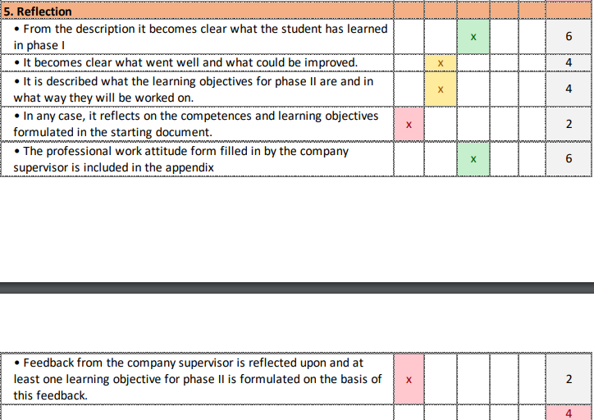

It becomes clear what went well and what could be improved.

It is described what the learning objectives for phase II are and in what way they will be worked on

In any case, it reflects on the competences and learning objectives formulated in the starting document.

Feedback from the company supervisor is reflected upon and at least one learning objective for phase II is formulated based on this feedback.

Appendices

5.1 Gantt chart

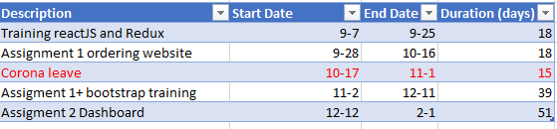

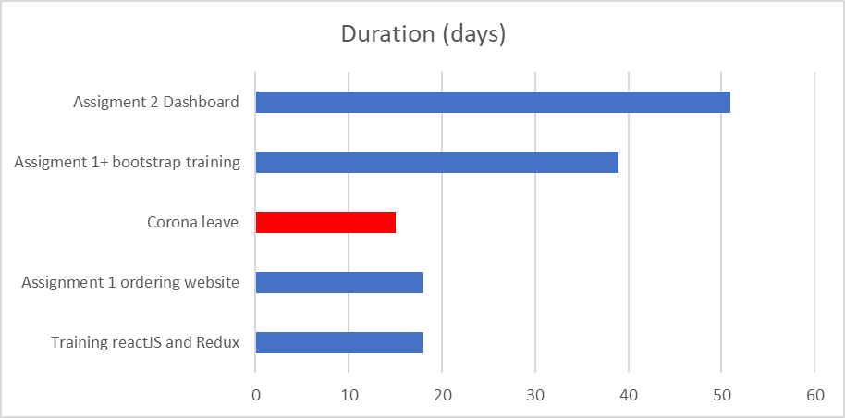

5.2 The contact details document

Simranjit Singh Grewal
Position: CEO, On site supervisor
Email: ssg@ythewait.com

Varun Dhamija
Position: Web development team leader
Phone number: +91 95697 91259

Divya Chauhan
Position: Frontend Developer
Phone number: +91 8437420894

Sumit
Position: Sr.Web Developer
Phone number: +91 80547 87652

Gurleen Kaur
Position: Associate project coordinator
Phone number: +91 75279 00797

5.3 The professional-attitude feedback form

